SEPT 30: Digital and Print Ads

Schools

St. Bernard of Clarivaux
- School & Parish (church bulletin)
  - Contacted 2143210454 & 2143212897 extension 101
- Status: No voicemail option for School number, left voicemail at church bulletin 9/30

Bishop Lynch
- Contacted Kristin Mannari 2143243607 ext. 4217
- Email option: Kristin.mannari@bishoplynch.org
- If searching for a known resource, refer to the link
  - http://www.bishoplynch.org/ContactUs
- Status: Left Voicemail 9/30

Wood Elementary PTA
- Contacted president Julie Gotliebb 8179653744
- Status: left Voicemail 9/29

TBD: SMU alumni publications, STA follow up 2148213360, St. Elizabeth Follow up

Local Publications (Mid Level Circulation):

White Rock Lake Weekly
- Submitted online form applying for print Ad prices
- Options
  - Print Ad
  - Web Ad
  - Classified Ad (Ready to Submit portal)
  - Article (on website)
  - Images (on website)
- Links
  - http://whiterocklakeweekly.com/customform.aspx?smid=14803
  - http://www.whiterocklakeweekly.com/
- Status: Need to get quote for website and print ads.

Lakewood Advocate
- See Folder for why to advertise and deadlines
- Options
  - Print Ad
  - Web Ad
  - Articles
  - Classified
  - Women In Business Section
- Contacted Judy Liles 2145604203
- Email option: jliles@advocatemag.com
- See link for further contact information: http://lakewood.advocatemag.com/about-us/contact/
- Status: Left voicemail 9/30

Forest Hills newsletter
- Options
  - Submit Ready Ad on Portal
  - Submit Articles
  - Print Ad – See image for Prices
- Links to submit articles and artwork Below
  - http://www.foresthillsdallas.org/submit_articles.htm
  - http://www.foresthillsdallas.org/submit_artwork.htm
- Status: Awaiting Action
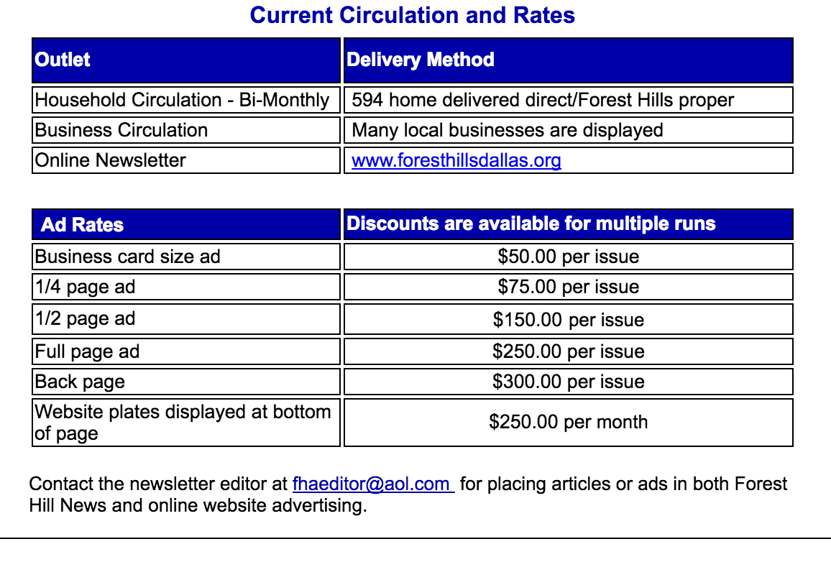

Religious Publications (Large circulation)

The Catholic Foundation
- Options
  - Donor Profile on the Good Word Publication
  - Colleen is on Advisory Board (discount?)
  - The Good Plan publication on Estate Planning- Potential for host to an entry in the Good advisor (See Folder)
  - E newsletter
  - News letter
  - Contacted Meghan Donnelly 9726619792
  - Email Option: mdonnelly@catholicfoundation.com
  - Article topics: about Donor, philanthropy, family
- Link: https://www.catholicfoundation.com/contact/
- Status: Left Voicemail 9/30

Texas Catholic
- Rates in PDF in Folder
- Accepts Article submissions and is an excellent example of a facebook and youtube social media presence for a classy business. See below for my personal notes and links
- Status: Awaiting Action

Major Publications (largest Circulation, vote internet instead of print)

Texas Lawyer

- Correspondence, Rates, and Sell point in folder
- Contacted and Spoke with Annette Planey via Phone and Email
-Options
-Featured Firm Space
-Digital, Print Ad, Lawyer of the Month, Construction
-Status: Waiting on our follow up

Dallas Business Journal
-Options (Digital)
- subscribe and feature women lawyers on BizWomen Publication --
-executive profile and business directory Featurette likely cheapest
-Featured Firm Space
-Digital, Print Ad, Lawyer of the Month, Construction

-Links:
http://mediakit.alm.com/brands/texas-lawyer/
http://acbj.com/brands/bizwomen
- Status: submitted Form for Media Kit

Construction News
-Contact Editor Melissa Jones Meyer 8177314823
-Email option: dfweditor@constructionnews.net
-Options
-Classifieds
-Lawyer Feature
-Article
-Status: Voicemail, Submitted Media Form
Dallas morning news
-Goal= Find a lawyer Search Engine
-Links:
http://local.dallasnews.com/search/en-US/search#!Dallas,TX/Lawyers/1/relevance/{}
http://dmnmedia.com/
-Status: Called, Awaiting email with prices for both digital and print options

Article notes
- (write a web article and submit a bio about dad (include SMU SBS BL puebla DCT ST JUDE; sacrament of marriage mom and dad, history of hosting young lawyers)
- Example for parents: https://www.youtube.com/user/txcatholicnewspaper
https://www.facebook.com/texascatholic

Other ideas
- Community feature on websites
- Submit articles
- SMU alimni
- D magazine
- Architect firms and websites
- Advertise on construction sites

TBD: D Magazine
People News Paper Park Cities
For advertising information, please contact publisher Pat Martin at 214-739-2244, or visit the People Newspapers website.

D Magazine
For advertising or sponsorship information, contact publisher Phyllis McKnight atphyllis@dmagazine.com
or call her at 214-523-5282.

D – 100$
http://advertise.dmagazine.com/media-kits/d-online/advertising-specifications/
Main Number:214.939.3636

